Manual of compact models for Perpendicular Magnetic Anisotropy (PMA) Magnetic Tunnel Junction (MTJ)
SPINLIB: Model PMA_MTJ
Version: PM_Beta_5
Y. Wang, Y. Zhang, W.S. Zhao, L. A. B. Naviner, H. Cai and
J-O. Klein
Fert Beijing Institute, BDBC and School of Electronic and Information Engineering,
Beihang Univeristy, Beijing 100191, China
Contact: weisheng.zhao@buaa.edu.cn
Table of contents
I. General Introduction
II. Files Provided
III. Parameters
III.A CDF
III.B Technology Parameters
III.C Device Parameters
IV. Function Option

- General Introduction
Magnetic tunnel junctions (MTJs) composed of ferromagnetic layers with perpendicular magnetic anisotropy (PMA) are of great interest for achieving high-density non-volatile memory and logic chips owing to its scalability potential together with high thermal stability. Recent progress has demonstrated a capacity for high speed performance and low power consumption through current-induced magnetization switching. In this manual, we present the utilization of a compact model of CoFeB/MgO PMA MTJ, a system exhibiting the best tunnel magneto-resistance ratio and switching performance. The MTJ structure consists of, from the substrate side, Ta(5)/Ru(10)/Ta(5)/Co₂₀Fe₆₀B₂₀(1.3)/MgO(0.85) /Co₂₀Fe₆₀B₂₀(1.3)/Ta(5)/Ru(5) (numbers are nominal thicknesses in nanometers) (see Fig1(a)). It integrates the physical models of static, dynamic and stochastic behaviors; many experimental parameters are directly included to improve the agreement of simulation with measurements.

The objective of this guide is to provide an easy way to start the simulation of hybrid PMA MTJ/CMOS circuits.
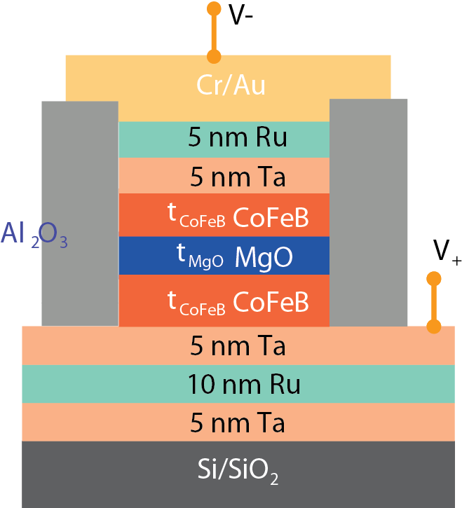
Fig.1. (a) Vertical structure of an MTJ nanopillar composed of CoFeB/MgO/CoFeB thin films.
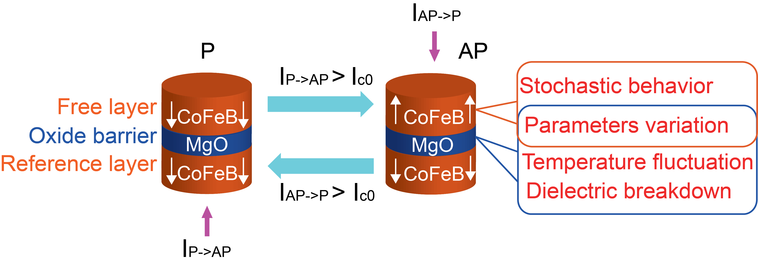
Fig.2. Spin transfer torque switching mechanism: the MTJ state changes from parallel (P) to anti-parallel (AP) as the positive direction current I_{P->AP}>I_{C0}, on the contrast, its state will return as the negative direction current I_{AP->P}>I_{C0}.The main provenance of reliability issues and the parameters of the related layers included in the model are indicated.

Programmed with Verilog-A language
Validated in Cadence 6.1.5 Spectre, CMOS Design Kit 28nm and 40nm.

- Files Provided
Decompress the compressed file PMAMTJ40_StoTem4_0.tar which you have downloaded (Attention: Never rename the model out of Cadence, or a hierarchical problem would occur. ).

There are three files included in the decompressed file:

The first file named “modelPMAMTJ” includes a script file of the type of veriloga, which is the source code of this model, and a symbol file (original symbol). In this file, there is also a sub file named “source.scs” which must be included as a “Global Model File”when a simulation is executed;
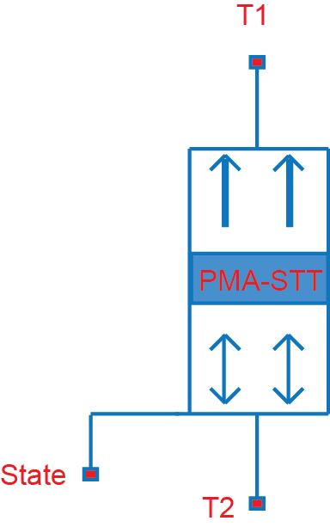
Fig.3 Symbol of the PMAMTJ model

The second file named “cellPMAMTJ” includes a package schematic designed with the original symbol and a symbol file of PMAMTJ (formal symbol).
This symbol contains three pins:

A virtual output pin “State” is used to test the state of MTJ. Its output must be one of the two discrete voltage-levels: level ‘0’ indicates the parallel state; level ‘1’ indicates the anti-parallel state.

Another two pins “T1, T2” are the real pins of the junction. These two pins aren’t symmetric: a positive current entering the pin “T1” can make the state change from parallel to anti-parallel.

Another file named “simuPMAMTJ” is a simple test simulation case using this model in order to demonstrate how it works. The schematic of the test simulation is shown in Fig.4. We apply a simple voltage pulse as input to generate a bi-directional current which can switch the state of PMAMTJ from parallel to anti-parallel or from anti-parallel to parallel. By monitoring the voltage-level of the pin “State” and the current values passing through the PMA MTJ, we can validate this compact model. The results of DC and transient simulations are presented in Fig.5 and Fig.6.

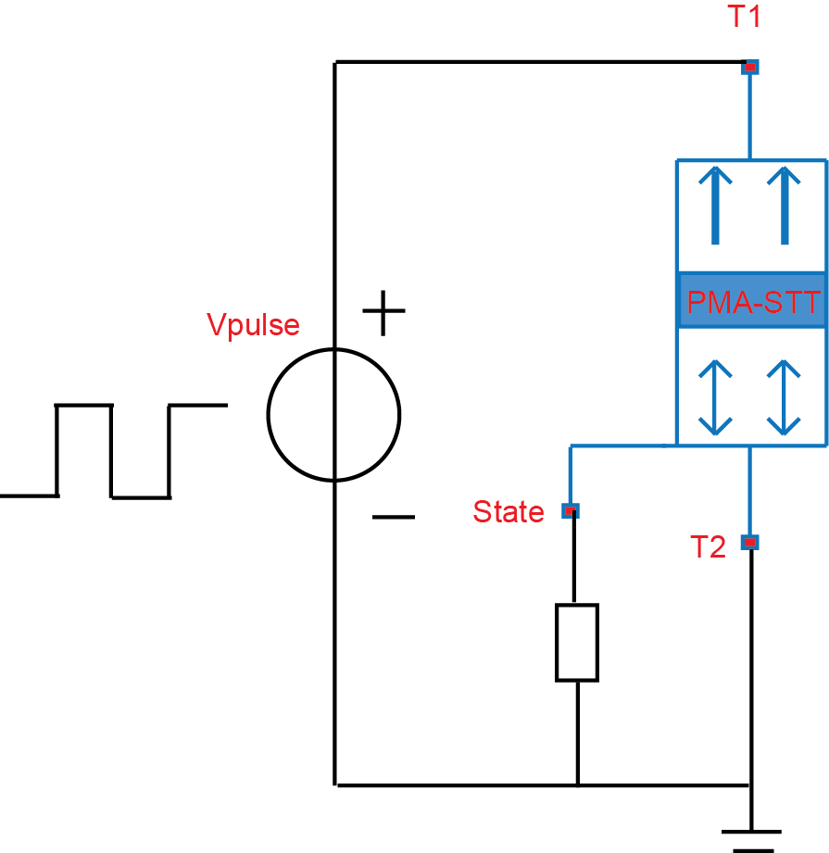
Fig.4 Schematic of the test simulation

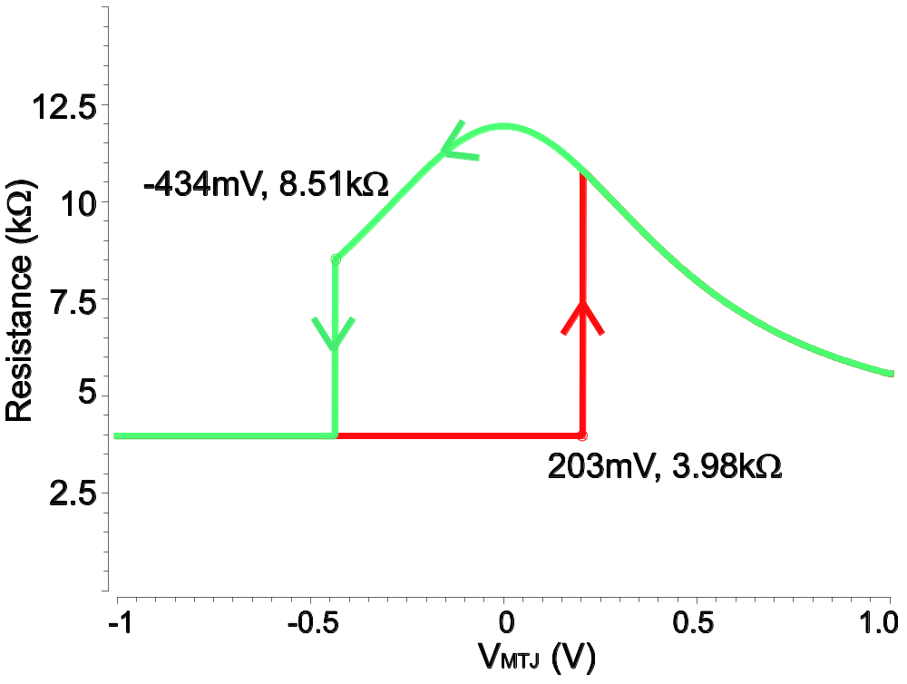
Fig.5 DC simulation of the PMAMTJ model
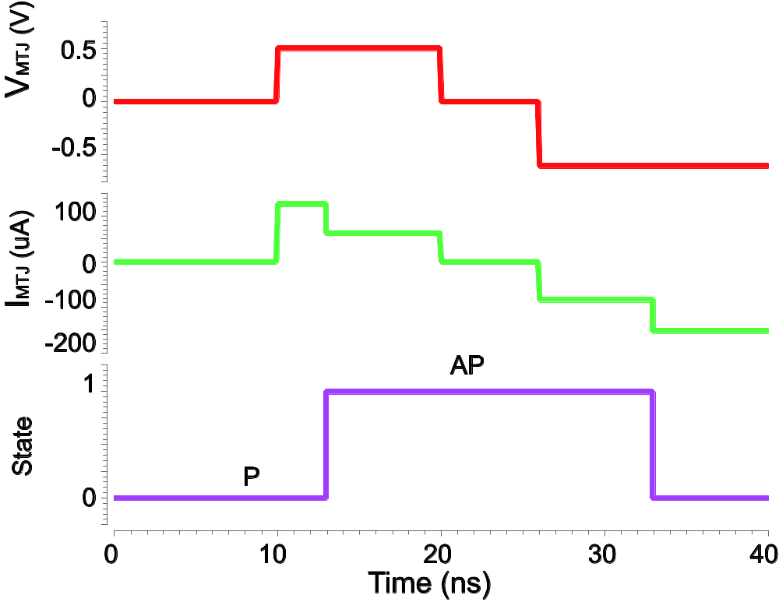
Fig.6 Transient simulation result of PMAMTJ model (without stochastic and variation effect)

- Parameters
III.A Component Description Format (CDF)
In order to describe the parameters and the attributes of the parameters of individual component and libraries of component, we use the Component Description Format (CDF). It facilitates the application independent on cellviews, and provides a Graphical User Interface (the Edit Component CDF form) for entering and editing component information.

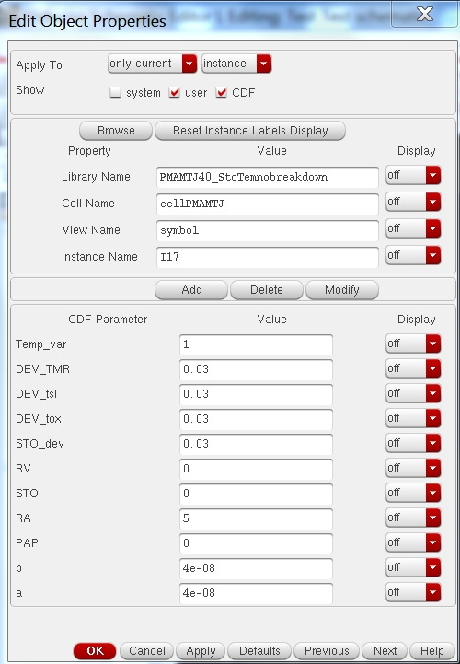

Fig.7 Modify the CDF parameters

Thanks to its favorable features, we use CDF to define the initial state of PMA MTJ. By entering “0” or “1” in the column “PAP” in category “Property”, we can modify the initial state to parallel or antiparallel (see Fig.7). Furthermore, using CDF tools we can modify multi MTJs’ states individually, which facilitates implementation of more complex hybrid CMOS/MTJ circuits.
If you need to define other parameters for this library, you can click Tools -> CDF -> Edit, enter “PMAMTJ” as the Library Name and “cell_PMAMTJ” as the Cell Name. Select “Base” as the CDF Type. Then click “Add” under Component Parameters. (see Fig.8)

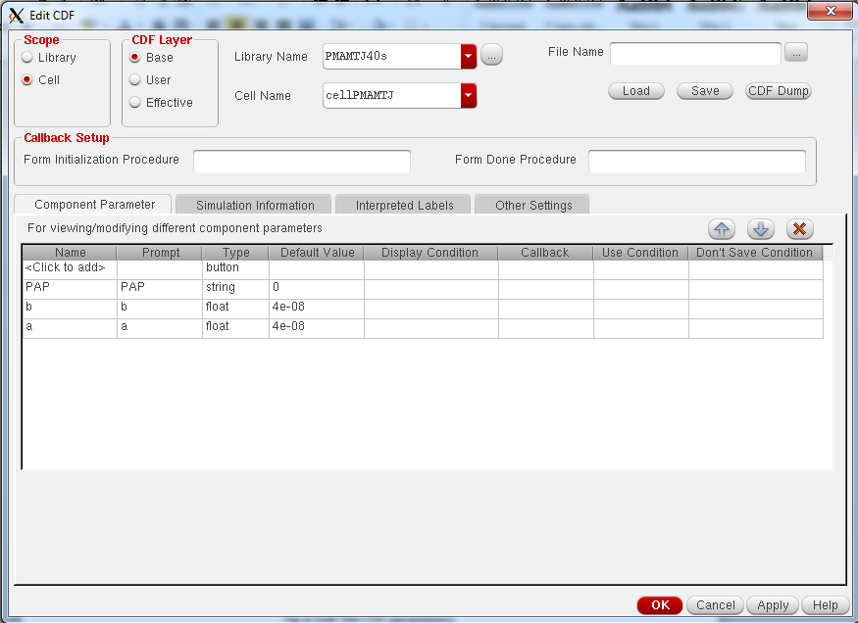
Fig.7 Edit the CDF parameters

Fill out the form as shown in Fig.7. You need to select the type of the parameter and enter the name and defValue of the parameter. Then click “OK”.

III.B Technology Parameters
Parameter | Description | Unit | Default value
alpha | Gilbert Damping Coefficient |  | 0.025
gamma | GyroMagnetic Constant | Hz/Oersted | 1.76e7
P | Electron Polarization Percentage |  | 0.52
Hk | Out of plane Magnetic Anisotropy | Oersted | 1734
Ms | Saturation Field in the Free Layer | Oersted | 15800
PhiBas | The Energy Barrier Height for MgO | Electron-volt | 0.4
Vh | Voltage bias when the TMR(real) is 0.5TMR(0) | Volt | 0.5
RA | Resistance area product | Ohmum² | 5 (5-15)

These technology parameters depend mainly on the material composition of the MTJ nanopillar and it is recommended to keep their default value.
III.C Device Parameters
Parameter | Description | Unit | Default value (Range)
tsl | Thickness of the Free Layer | nm | 1.3 (0.8-2)
a | Length of surface long axis | nm | 40
b | Width of surface short axis | nm | 40
tox | Thickness of the Oxide Barrier | nm | 0.85 (0.6-1.2)
TMR | TMR(0) with Zero Volt Bias Voltage |  | 200% (50%-600%)

These device parameters depend mainly on the process and mask design and the designers can change them to adapt their requirements.

The default shape of MTJ nanopillar surface is circular (a=b), but we can use also ellipse for specific simulation purposes.
- Function Option
Beyond the static and dynamic behaviors, this model can as well operate with STT stochastic switching and resistance variation effect.

STT stochastic switching: it results from the unavoidable thermal fluctuations of magnetization. They are responsible for large fluctuations in the switching duration, the latter following a sigmoidal distribution with exponential tails. Because of this phenomenon, some write errors might occur. For instance, desired data may not be correctly stored in writing operation and unexpected switching may happen in sensing operation. This phenomenon deeply affects the reliability of hybrid CMOS/MTJ circuits.

Resistance variation: As the limit of the manufacturing technology, the actual thickness of oxide layer and free layer cannot be fixed at one constant value that we expected. They always vary in a somewhat small range, but can lead to a relatively important variation for MTJ resistance. In addition, we also take the TMR ratio variation into account. The variations for these three parameters are ± 1%. (see Fig.9).

Temperature evaluation: In spite of optimisation in the past several years, a large current density of several MA/cm2 is always needed for current-induced magnetization switching [20, 8], which heats up the MTJ due to Joule heating. The increase of temperature has an important impact on the switching delay. This model offers the users the choice of considering the temperature increase due to Joule heating during current pulse.

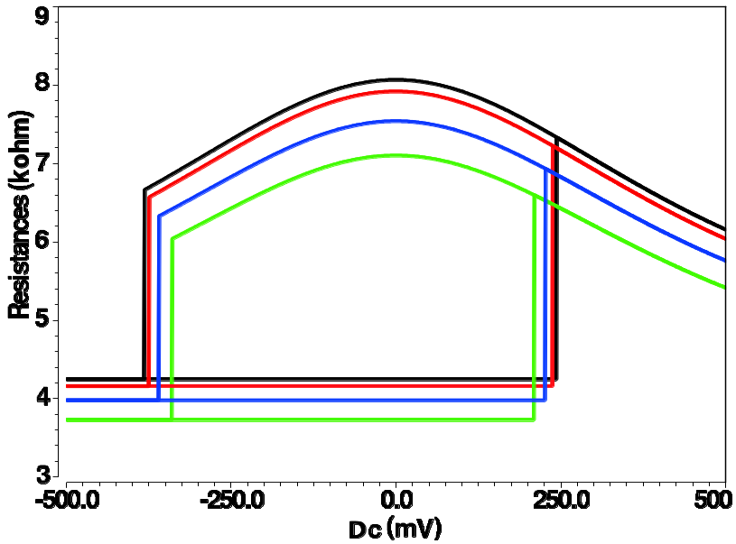
Fig.9 Monte-Carlo statistical simulation (4 times) of the STT PMA MTJ with key parameter variations: σtox=1%, σTMR=1% and σtfree=1%.

In order to choose which effect being integrated, a convenient CDF parameter window is provided for configuration. As shown in the Fig.6, “STO” represents “STT stochastic switching” and “RV” represents “Resistance variation”. ‘0’ is to disable it , ‘1’ is to choose uniform distribution for resistance variation and exponential distribution for stochastic switching, ‘2’ is to choose Gaussian distribution for both.

The following parameters shown in Fig.7 can be used to describe STT stochastic switching, Resistance variation and Temperature evaluation. The users are free to define the value of these parameters in order to investigate the impact of different parameter:
Parameter | Description
 | Value | Behavior
Temp_var | 0 | Temperature fixed as T=300K
Temp_var | 1 | Temperature changes because of Joule heating
RV | 0 | Device parameters constant
RV | 1 | Device parameters follow an uniform distribution
RV | 2 | Device parameters follow a Gaussian distribution
DEV_TMR | 0.03 | Variation percentage of TMR when RV=1,2
DEV_tsl | 0.03 | Variation percentage of tsl when RV=1,2
DEV_tox | 0.03 | Variation percentage of tox when RV=1,2
STO | 0 | Switching duration constant
 | 1 | Switching duration follows an exponential distribution
 | 2 | Switching duration follows a Gaussian distribution
STO_dev | 0.03 | Variation percentage of switching duration when STO=2

The values of DEV_TMR, DEV_tsl, DEV_tox and STO_dev can be freely chosen, but it’s recommended to choose values around the default values and avoid choosing very high values. Some examples for introducing this “Function Option” is as follows:

Case 1: only with STT stochastic switching (‘1’ for “STO” and ‘0’ for “RV”) (see Fig.9)

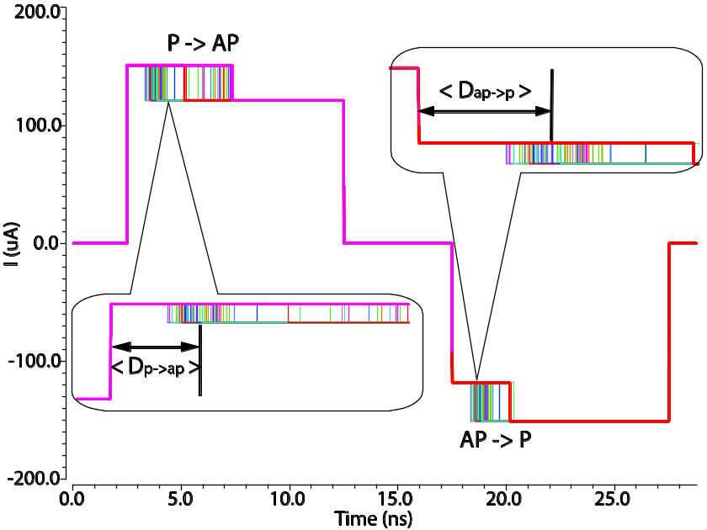
Fig.10 100 complete STT stochastic switching operation simulations (parallel (P) to antiparallel (AP) and back to parallel (P))

Case 2: with both STT stochastic switching and resistance variations (‘1’ for both “STO” and “RV”) (see Fig.11)
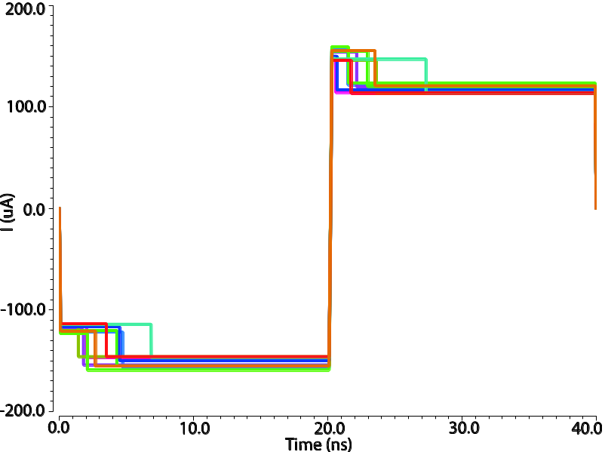
Fig.11 10 complete writing operation simulations with both STT stochastic switching and resistance variations (antiparallel (AP) to parallel (P) and back to AP)
Case 3: With both STT stochastic switching and resistance variations (‘2’ for both “STO” and “RV”) and the device parameters and duration follow Gaussian distribution with a variation of 0.03(see Fig.11)

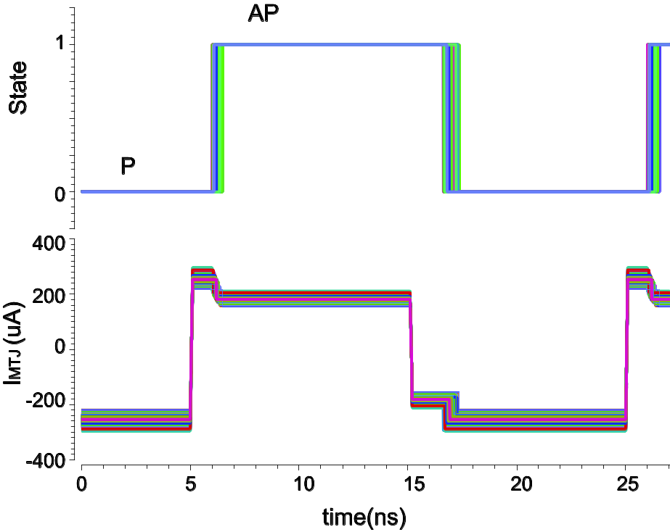
Fig.12 200 complete writing operation simulations with both STT stochastic switching and resistance variations (antiparallel (AP) to parallel (P) and back to antiparallel (AP))
Case 4: Temperature changes because of Joule heating (Temp_var=1)(see Fig.12)
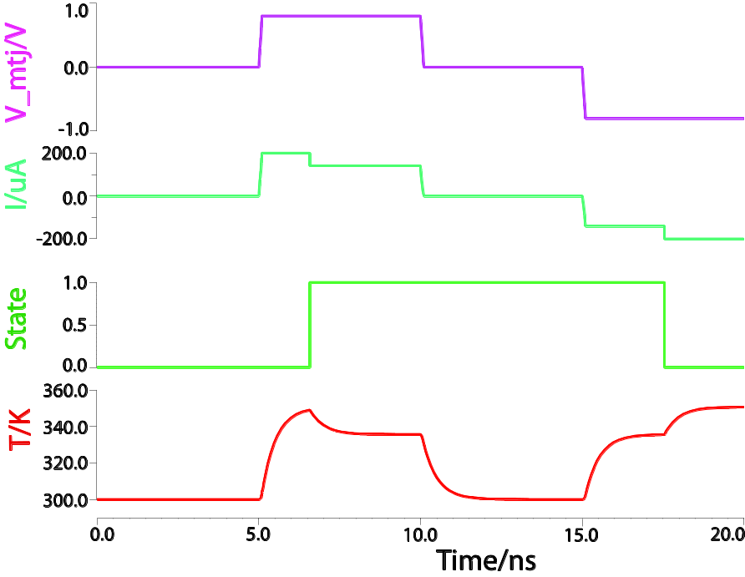
Fig.12 Temperature evaluation when the state of MTJ from P to AP and from AP to P
Case 5: Temperature dependence of resistance value R, critical current Ic0 and duration (see Fig.13, Fig.14). Just change the simulation temperature by using the function “Parametric analysis” under the “Tools” in ADEL interface.
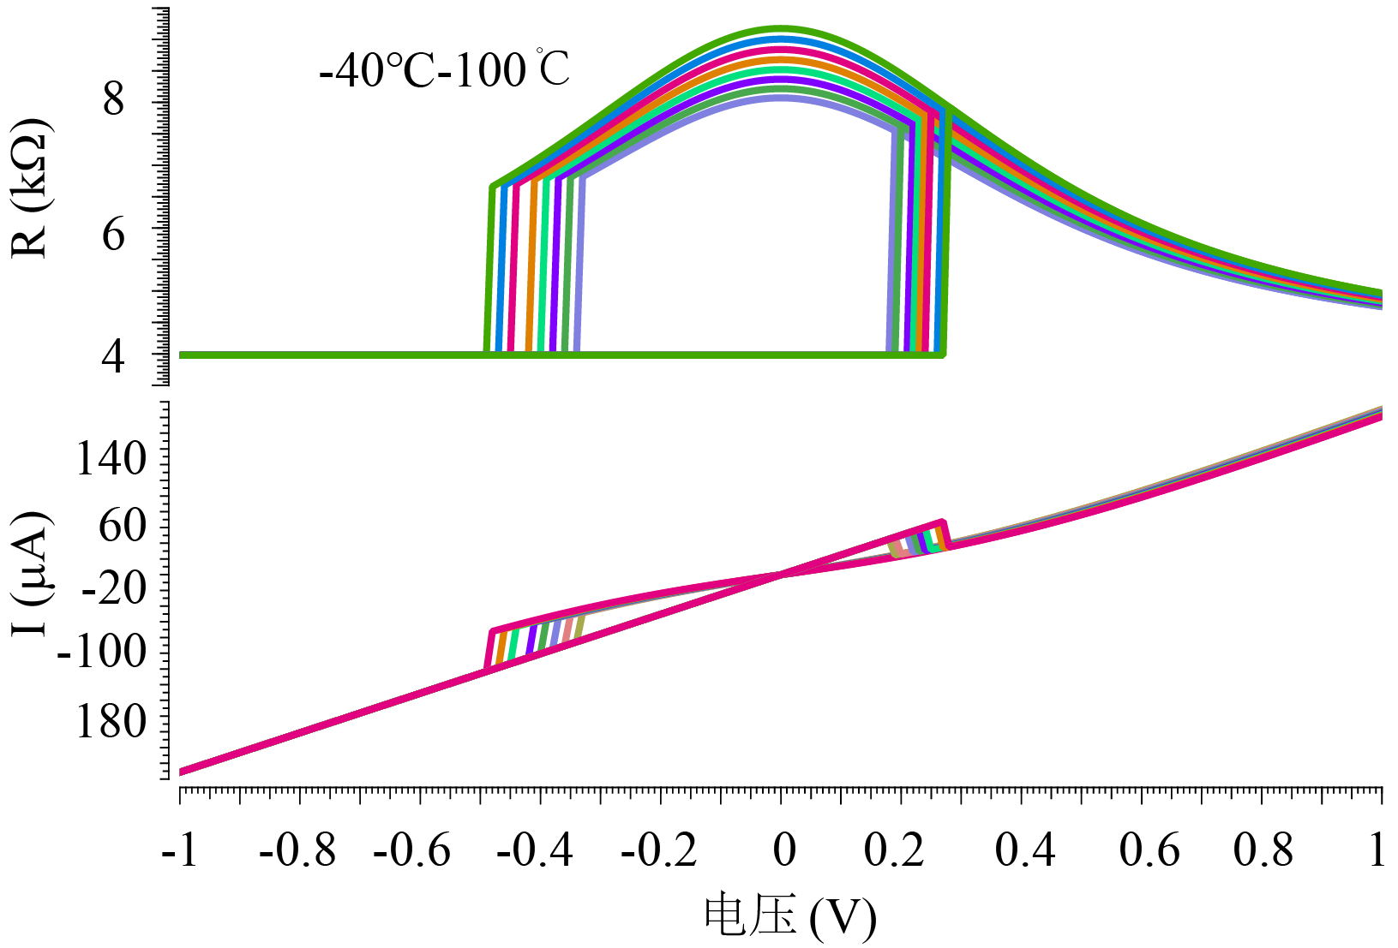
Fig.13 Temperature dependence of resistance and critical current

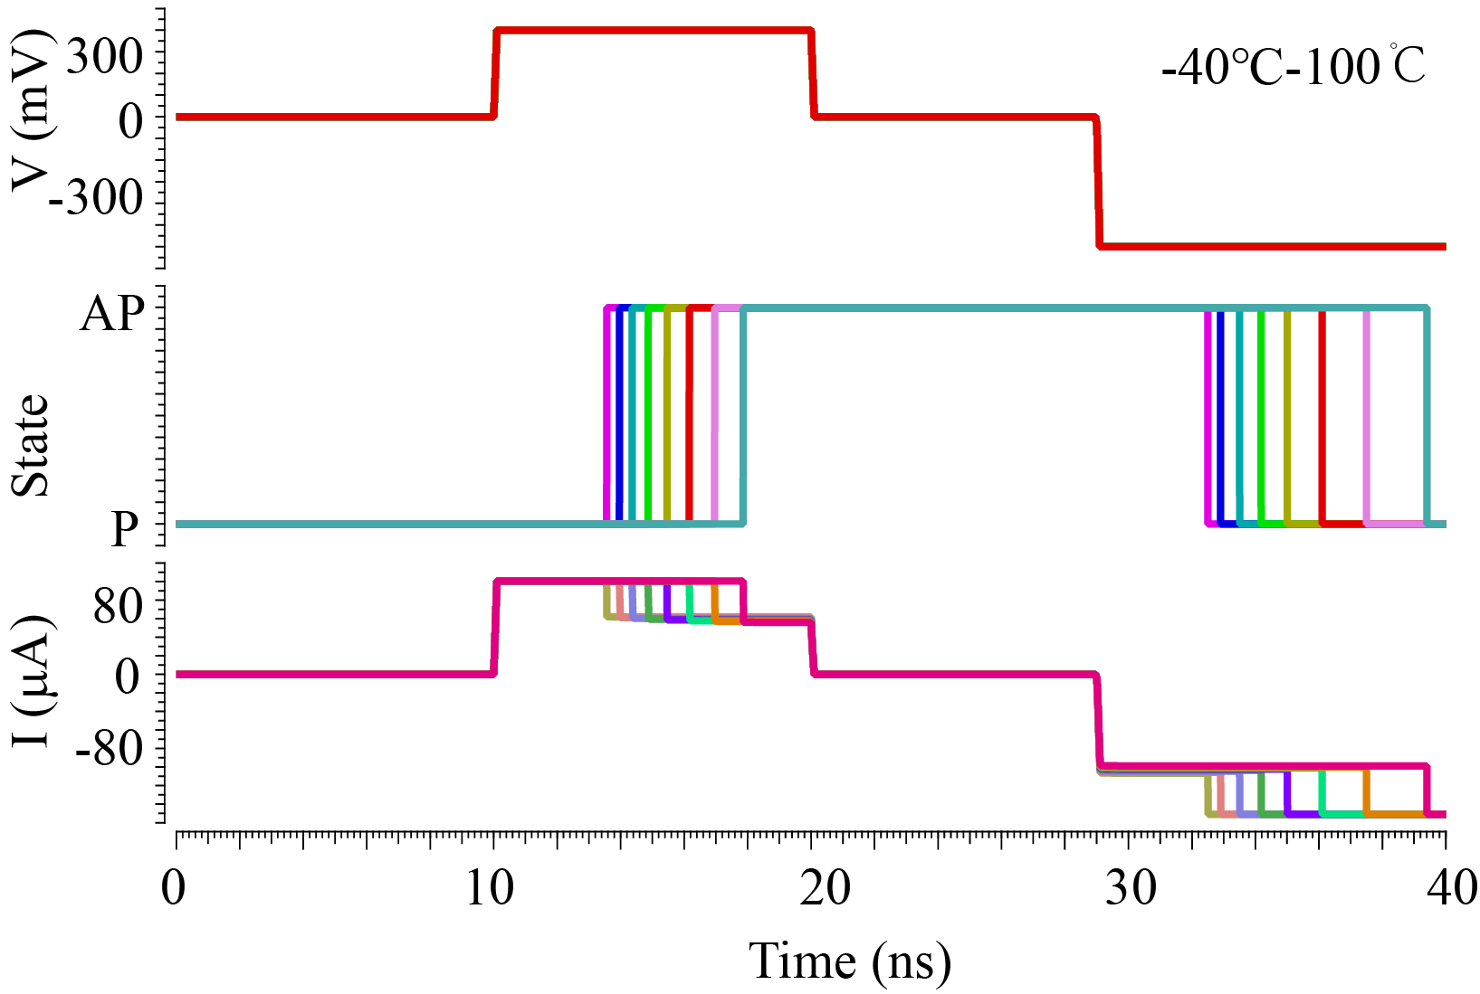
Fig.14 Temperature dependence of current and switching duration

- Before simulation
- When you launch ADE L for a new simulation under Cadence, check if you have added “veriloga hdl” in the “switch view list” from “Setup”.
- Check if you have added “source.scs” in the model file “modelPMAMTJ” from root file “PMAMTJ40_StoTem4_0” to the “Model Libraries” in “Setup”.
- Check if the Temperature setting is “27”(300K).
- Check if there are user parameters or variables which are not aligned with appropriate values.
Start the simulation after having four “yes” for the questions above.
If the parameter values of your MTJ is very different from ours, you can modify the parameters as follows:
- Open the file cellPMAMTJ->schematic

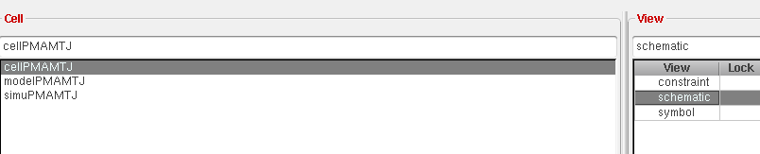

- Click modelPMAMTJ->properties

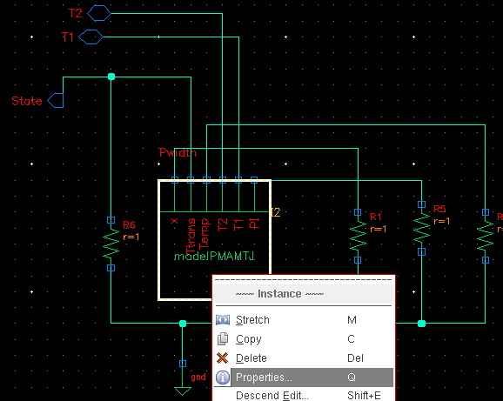

- Then configure the parameters as you want:
